Elsie Gnana Shiney Dasari 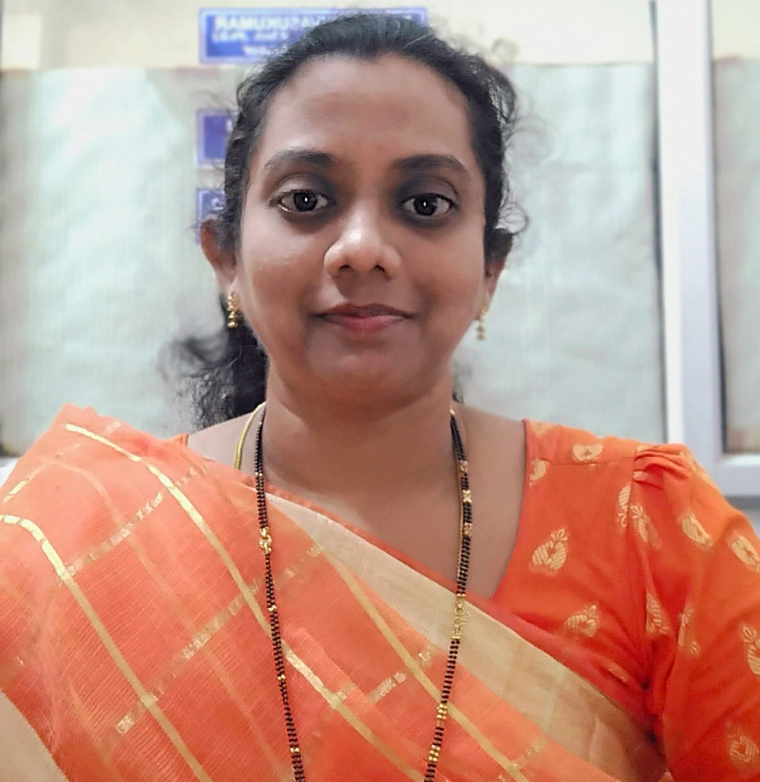

shineycharles@gmail.com | 8658603130

CAREER OBJECTIVE:

To work as a faculty for Computer Science in a reputed organization.

# EDUCATIONAL QUALIFICATIONS:

* M.Tech (Computer Science and Technology) - Andhra University College of Engineering, Visakhapatnam, A.P (September 2010) | 8.01 CGPA
* B.Tech (Electronics and Computer Engineering) - Akula Gopaiah College of Engineering and Technology affiliated to Jawaharlal Nehru Technological University, A.P (April 2007) | 63.25%
* Intermediate (Mathematics, Physics & Chemistry) - Vijaya Junior College, Machilipatnam, A.P (March 2003) | 75.5%
* S.S.C - Nirmala High School, Machilipatnam, A.P (March 2001) | 64.6%

# EXPERIENCE: 11 Years 10 Months

* Assistant Professor - Seshadri Rao Gudlavalleru Engineering College, Department of Information Technology (July 2022 - Present)
* Computer Faculty - The Leprosy Mission Vocational Training Center (TLMVTC), Vizianagaram (January 2020 - June 2022)
* Java Faculty - St. Joseph English Medium School, Parlakhemundi, Odisha (April 2015 - December 2019)
* Assistant Professor - Department of CSE & IT, Centurion University, Paralakhemundi (February 2011 - December 2011)
* Assistant Professor - Sri Sunflower College of Engineering, Lankapalli, Machilipatnam, Krishna District, A.P (June 2010 - September 2010)
* Assistant Professor - Computer Science Department, P. Indra Reddy Memorial College of Engineering, Chevella, Ranga Reddy District (September 2007 - September 2008)

# ONLINE CERTIFICATIONS:

* NPTEL Online Certification in Operating System Fundamentals with Elite
* NPTEL Online Certification in Data Mining with Elite
* NPTEL Online Certification in Java Programming with Elite
* EdX Certificate on “Deep Learning with TensorFlow”
* EdX Certificate on “AI for Everyone: Master the Basics”
* EdX Certificate on “Introduction to Web Development with HTML5, CSS3 and JavaScript”
* EdX Certificate on “Introduction to Java Programming: Writing Good Code”
* EdX Certificate on “Machine Learning with Python: A Practical Introduction”
* EdX Certificate on “Python Basics for Data Science”
* EdX Certificate on “Business Consideration for 5G with Edge, IoT, and AI.AWS-OTP-AWSD15: AWS Cloud Practitioner Essentials”

# FACULTY DEVELOPMENT PROGRAMS:

* Participated in 6-Days FDP on “ARDUINO APPLICATIONS IN ENGINEERING” - Seshadri Rao Gudlavalleru Engineering College (11-03-2024 to 16-03-2024)
* Participated in 5-Days FDP on “New Age Technologies” - SCOPE, VIT-AP University, Amaravati (28-03-2023 to 01-04-2023)
* Participated in 6-Days FDP - Seshadri Rao Gudlavalleru Engineering College in association with SkillDzire Technologies Private Limited (06-03-2023 to 14-03-2023)
* Participated in a webinar on “Guidelines for Getting Funding for Projects from Various Funding Agencies” - Punjabi University Patiala (09-06-2023)
* Attended a 6 Days refresher course on Principles of Compiler Design - Seshadri Rao Gudlavalleru Engineering College (22-01-2024 to 27-01-2024)
* Attended 6 Days workshop on “Challenges And Research Opportunities In Deep Learning And Machine Learning” - Seshadri Rao Gudlavalleru Engineering College (02-01-2023 to 07-01-2023)

**SUBJECTS TAUGHT SO FAR:**

* Data Warehousing And Data Mining
* Operating Systems
* Object Oriented Programming Through Java
* Mobile Application Development
* Software Engineering

# PAPER PUBLICATIONS:

* Exploring Optimal Cluster Quality in Health Care Data (HCD): Comparative Analysis Utilizing k-means Elbow and Silhouette Analysis - International Journal of Chemical and Biochemical Sciences, ISSN 2226-9614 (Feb 2024, Vol 25-issue 16, page no: 48-60) (SCOPUS)
* Cloud-Enhanced Traffic Sign Classification With Wandb Journal of Advanced Zoology ISSN: 0253-7214 Volume 45 Issue S2 Year 2024 Page 123-130.
* Machine Learning Approach For Early Prediction Of Low Birth Weight Cases Journal of Advanced Zoology ISSN: 0253-7214 Volume 45 Issue S-2 Year 2024 Page 157-164
* Presented a paper on “The Identification of Melanoma Lesions Through the Use of Deep Learning Network and Cloud Computing” at 7th International conference on Intelligent Computing and control Systems(ICICCS 2023) organized by Vaigai College of Engineering ,Madurai,India on May 17-19,2023.

# PATENT:

System for Remote Monitoring and Diagnostic of Cyber Security Using Machine Learning - The Patent Office Journal No. 47/2022 (Dated 25/11/2022)

# PERSONAL INFORMATION:

Name: D. Elsie Gnana Shiney

Date of Birth: 3rd October 1985

Languages Known: English, Telugu, Hindi

Marital Status: Married

# DECLARATION:

I hereby declare that all the above particulars are correct and true to the best of my knowledge.  
  
 (D.E.G. Shiney)